INTRODUCTION

Welcome to the documentation for LHCSA (Licensed Home Care Services Agency) and ALP (Assisted Living Program) LHCSA Statistical Report using the Universal Data Collection System (UDCS), a data collection tool that enables you to enter data for submission to the Department of Health in a spreadsheet-like environment. In the past the platform used to collect the Statistical Report information was the Health Electronic Response Data System (HERDS). This has been upgraded to UDCS because it offers a more familiar, Excel-like interface and more powerful editing capabilities.

A UDCS data collection application has two parts – the UDCS Report Manager and Shell, which manage the reports on your computer and is like the Microsoft Excel executable, and the reports or formats that correspond to spreadsheets. This document will guide you through the process of downloading and installing the UDCS Report Manager and Shell and the reports.

NOTES:
- A Health Commerce System (HCS) account is required to download the UDCS Report Manager, Shell, and the reports.
- The Report Manager requires Windows 7 or later operating system. The software WILL NOT operate correctly with previous operating systems such as Windows Vista or Windows XP and CANNOT be run on an Apple computer.
- If the UDCS 2018 LHCSA Statistical Report software is installed on your computer, it must be uninstalled before this year’s software can be installed. The uninstall can only be done by some one with Windows Administrator privileges on the computer.
- The software, executables and reports, must be installed on the computer of the user who will be entering and submitting the data. The user installing the software must have Windows Administrator privileges on the computer on which it is being installed. The Windows Administrator must not use the “Administrator Shortcut” – where the user is signed on to the computer, but the Administrator right clicks and chooses “Run as Administrator”. The Administrator must sign on to the computer.
- Only users who have been assigned the HCS Administrator role when the application is released will be able to submit data. Other users can be added afterward but a request must be sent to HCStatRpts@health.ny.gov after the user has been assigned the HCS Administrator role.
- A single data file (this file has an extension of .pnp) should be created for each licensed site that your organization operates.
- A single copy of the data file can be stored in a location where multiple people can access it. This will enable people to enter the data that is appropriate for their organizational function – e.g. business office personnel entering the cost and revenue data and human resources personnel entering staffing and wages data. HOWEVER, ONLY ONE PERSON SHOULD ENTER DATA AT A TIME. If multiple people are entering data at the same time, only the data from the last person who saved will be retained.

UNINSTALLING PREVIOUS SOFTWARE

IMPORTANT NOTE: The Report Manager software has been updated for the 2018 Statistical Report. If you downloaded the software last year you must uninstall the software and re-install the newest version.

To uninstall software:

On Windows 10:
Go to Settings – Apps
Click on UDCS Report Manager
Click Uninstall

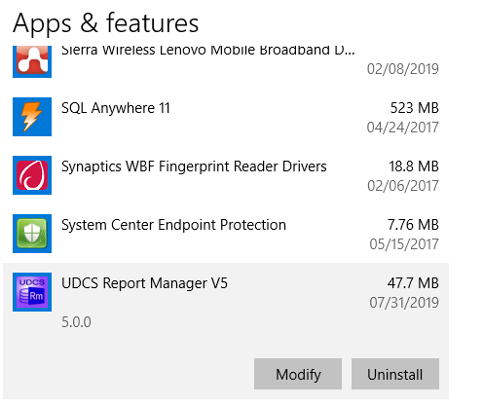

If you are not the administrator on your computer, you may be required to ask your IT Department to do the uninstall and installation.
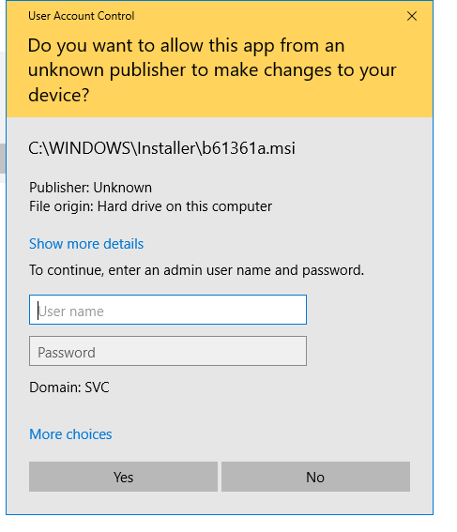

Installing the Software, Reports and Documentation

- Login to the HCS.
- Click on Healthcare Financial Data Gateway in My Applications.
- If it is not there:
  - Click on the My Content tab at the top of the HCS home page.
  - Click on All Applications.
  - Click on H in the Browse by alphabet list.
  - Click on the green sphere marked with a plus sign (+) on the row for the Healthcare Financial Data Gateway.
  - Go back to My Content.
  - Click on Healthcare Financial Data Gateway in My Applications.

This will take you to the Healthcare Financial Data Gateway main page.

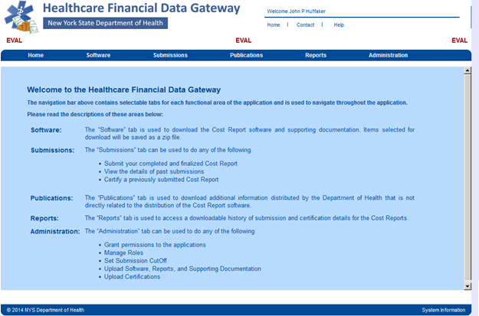

Installing the Software

- Go to the Healthcare Financial Data Gateway main page.
- Click on the Software tab – the Software, Reports and Documentation page will display

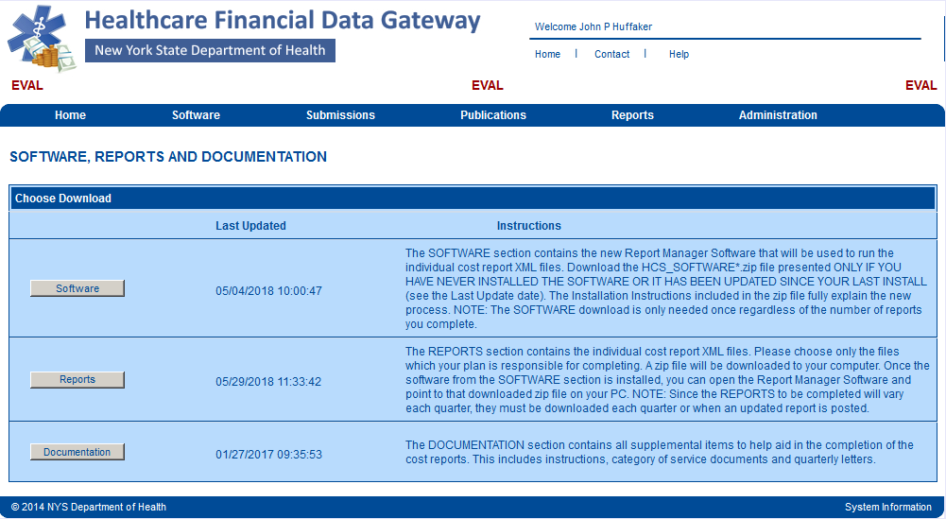

- Click the Software button– the Download Software page will display.

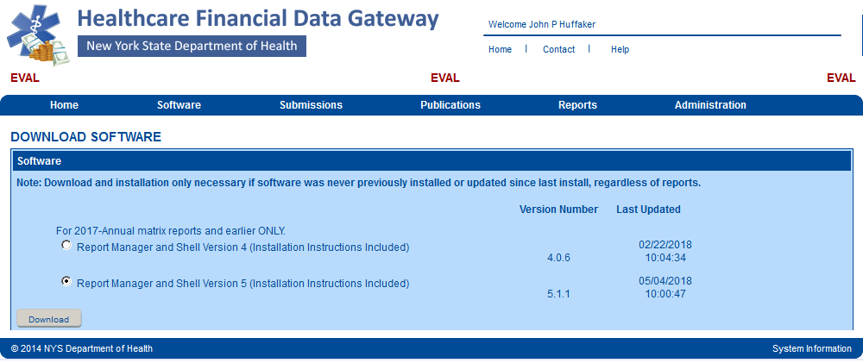

- Select Report Manager and Shell Version 5 (Installation Instructions Included).
- Click on the Download button at the bottom of the page.
- Save the .zip file to the location of your choice.
7 Open the .zip file and extract the Report Manager and Shell software and the installation documentation (this documentation is more extensive than is required to install the software for the Statistical Report and contains some information not applicable to LHCSAs).

Installing the Software continued…

- Run the UDCS_REPORT_MANAGER_SETUP_<version>.exe program. The Installshield Wizard splash screen will display after some initializations are performed. Click Next.

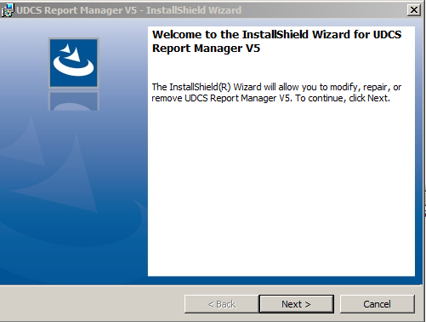

- The Program Maintenance dialog will display. Select Modify and click Next.
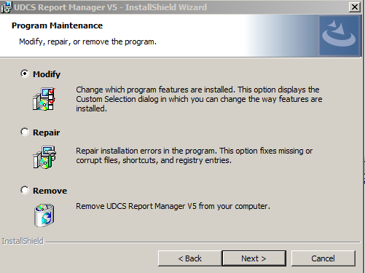

Installing the Software Continued…

- The Custom Setup dialog screen will display. Click Next.

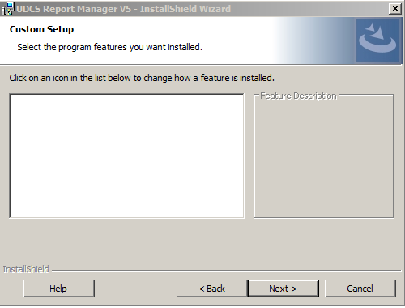

- The Ready to Modify the Program dialog will display. Click Install.

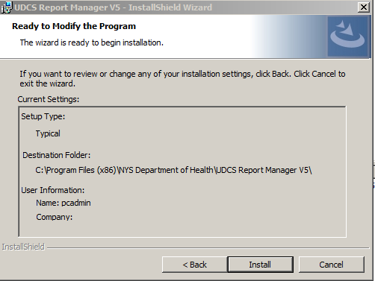

- A Desktop icon will be created named Launch Report Manager V5. Use this to launch the application.
Installing the Reports
Downloading the Reports

- Go to the Healthcare Financial Data Gateway main page.
- Click on the Software tab – the Software, Reports and Documentation page will display.

- Click on the Reports button – the Download Matrix Reports page will display.
  - Organization Type is Home and Community Based Services
  - Submission Schedule can be Annual LHCSA or Annual ALP_LHCSA
  - Submission Year is 2018
  - Submission Period is Annual
- Click on the Search button.

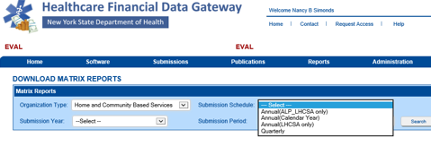

Downloading the reports continued…

- Unselect all reports except for the LHCSA-2018 Annual report and click the Download button.

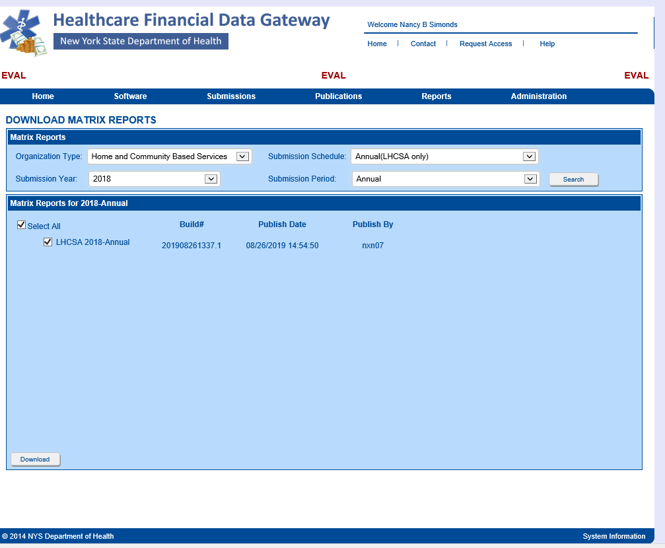

- DO NOT OPEN THE .zip FILE. Save the .zip file to the location of your choice. Some computers automatically save the downloaded .zip file into the computers Download folder. If your computer does not ask where you would like to save the file, it has most likely automatically saved the file in the Downloads folder. Do not modify this .zip file – it contains an encrypted file and can only be used by the UDCS Shell. Instructions for managing this file with the UDCS Report Manager and using it with the UDCS Shell are contained later in this documentation.

Running the Application

Running the application for the first time

- Click the Launch Report Manager desktop icon.
- The UDCS Select a Report dialog will display. Click the Add Downloaded Report button.

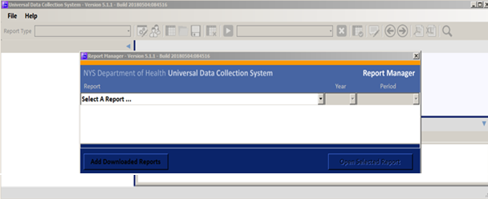

- Locate and select the report for the LHCSA-2018 annual report that you downloaded earlier

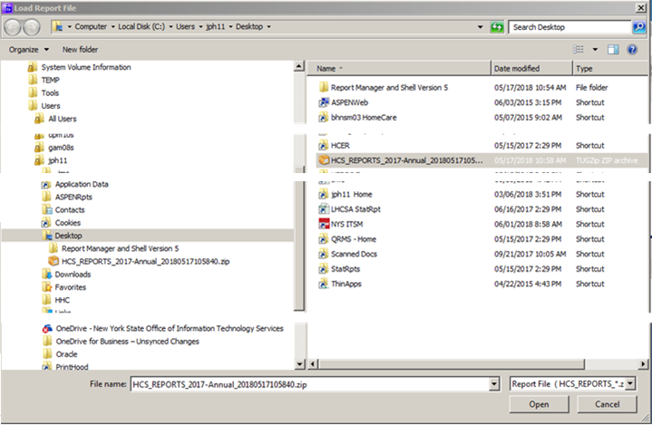
Running the Application for the First Time, continued…

- Click the down arrow at the end of the Select a Report… drop down menu and click on either the LHCSA Statistical Report menu item, or the ALP LHCSA Statistical Report item. Then select the correct year for the report.

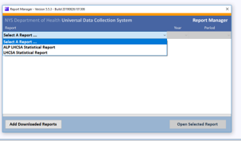

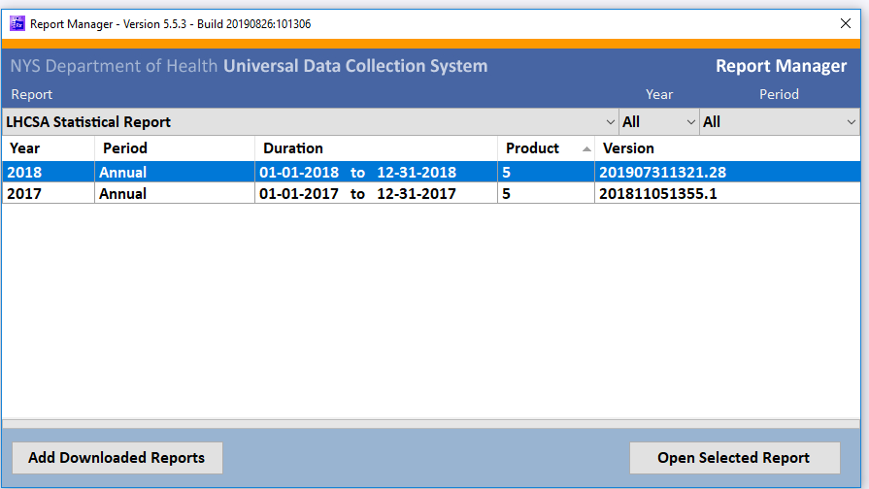

- This will load the report into the UDCS Report manager

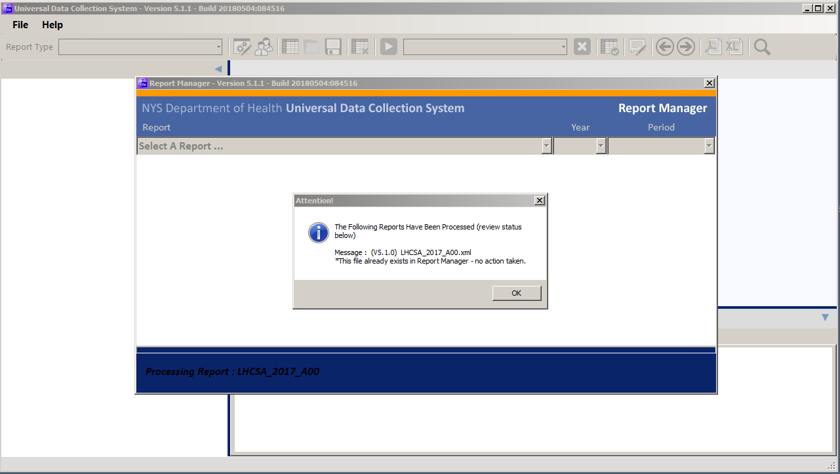

- Make sure that the correct report is selected and click the Open Selected Report button – the Start Report dialog will display

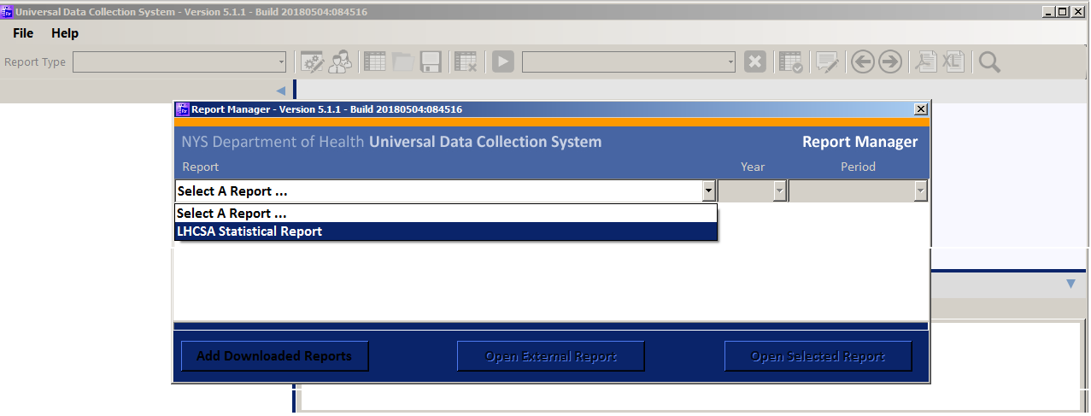

Running the Application for the First Time, continued…
- Click the Start New Report button

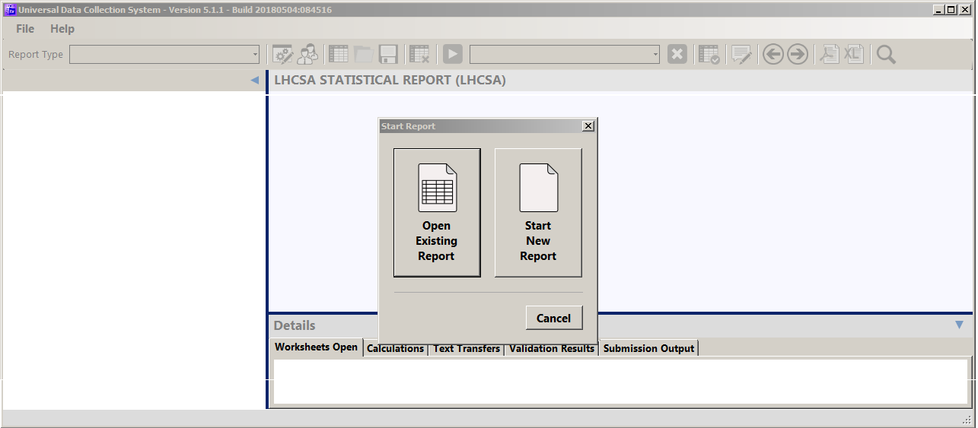

Running the Application for the First Time, continued…

- Click the OK button on the Select Report Type dialog – the Configure Report Organization dialog will display. Select your LHCSA from the Organization dropdown menu

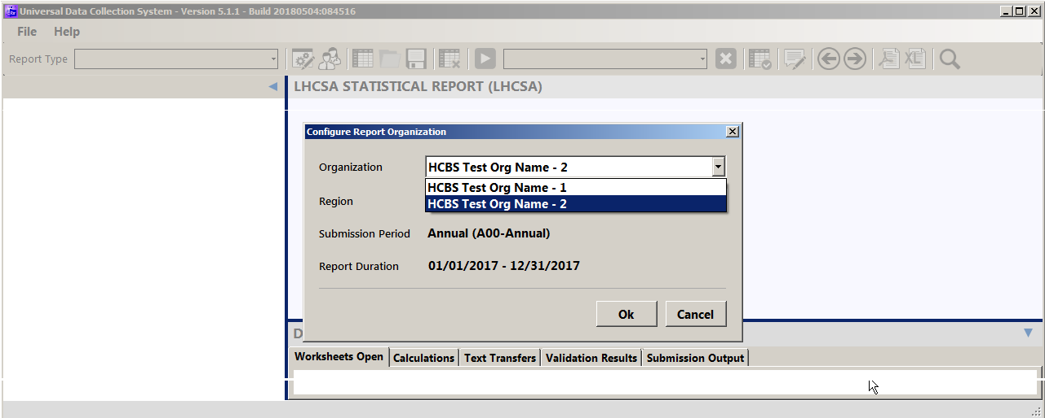

- Select Statewide from the Region dropdown menu click the OK button.

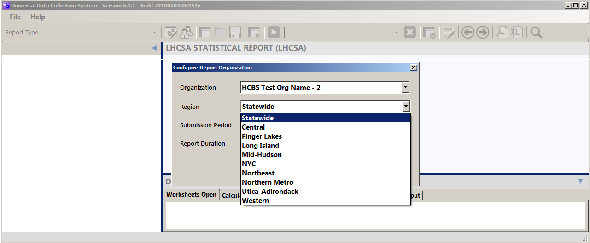

Running the Application for the First Time, continued…

- Click the OK button on the Save Report Configuration dialog.

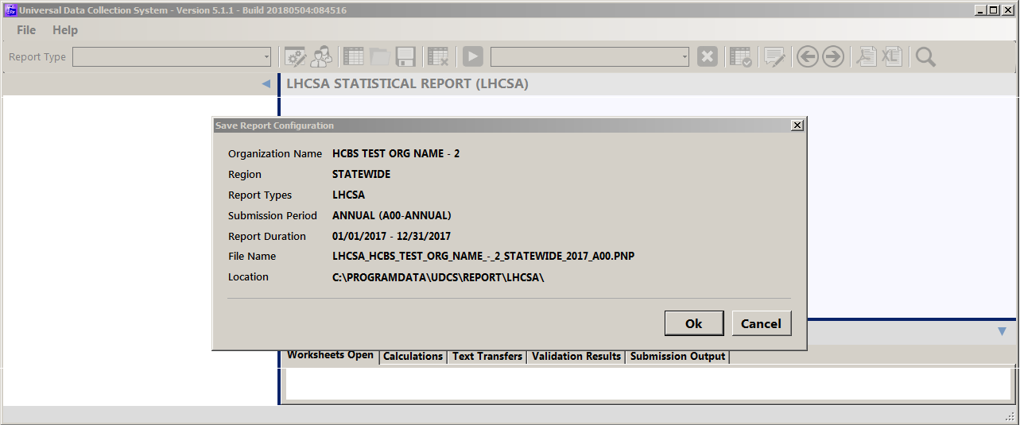

- The Universal Data Collection System Shell will start loading the selected report.

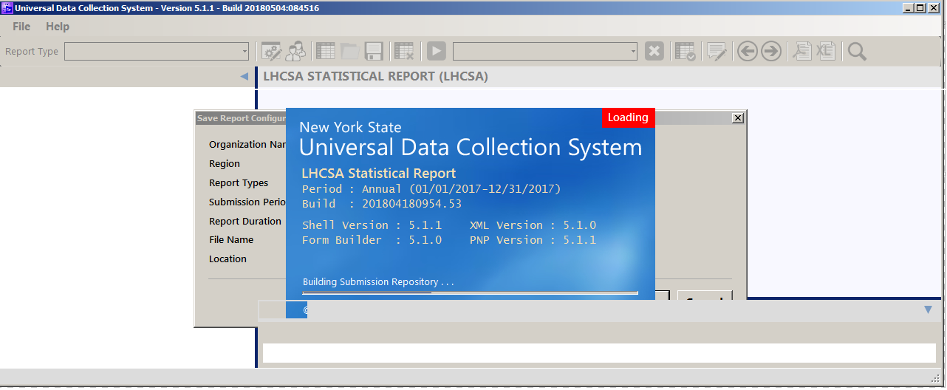

Running the Application for the First Time, continued…

- The Control Data Validation Message dialog will display; click the Yes button.

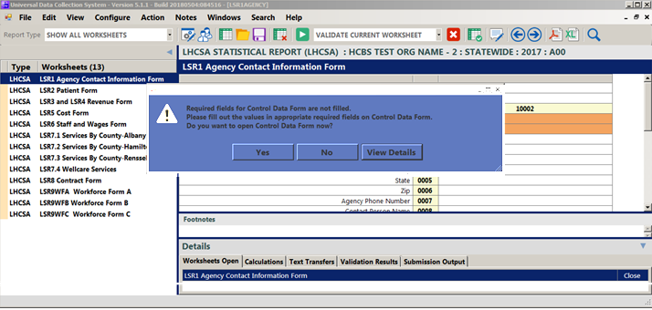

- File out the General Information data and Click the Validate button.

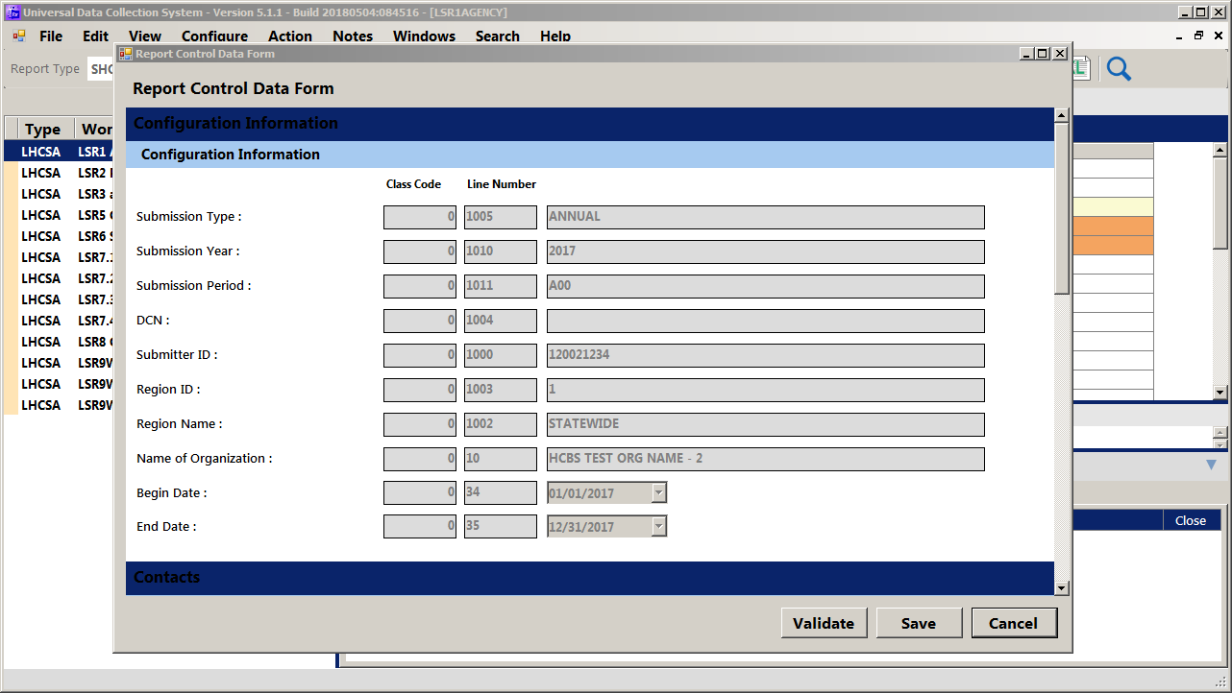

- If the data validates, click the Save button.
- Start entering data into the LHCSA Statistical Report or the ALP_LHCSA Statistical Report.

Running the application after the first time

- Click on the Launch Report manager desktop icon
- The UDCS Select a Report dialog will display
- Click on the down arrow at the end of the Select A Report… drop down menu
- Select the LJHCSA Statistical Report menu item
- Click on the Open Selected Report button – The Start Report dialog will display
- Click on the Open Existing Report button
- When File Explorer opens, select the report created when the application was initially started and open it.
- The Universal Data Collection System Shell will start loading the selected report
- If you have not yet entered the Configuration Information data
  - the Control Data Validation Message dialog will display; click on the Yes button
  - File out the Configuration Information data
  - Click on the Validate button
  - If the data validates, click on the Save button
- Continue entering data into the LHCSA Annual Statistical Report

Submitting the Finalized Statistical Report

- Login to the HCS.
- Click on Healthcare Financial Data Gateway in My Applications. This will take you to the Healthcare Financial Data Gateway main page.

- Click the Submissions tab – the Submissions page will display

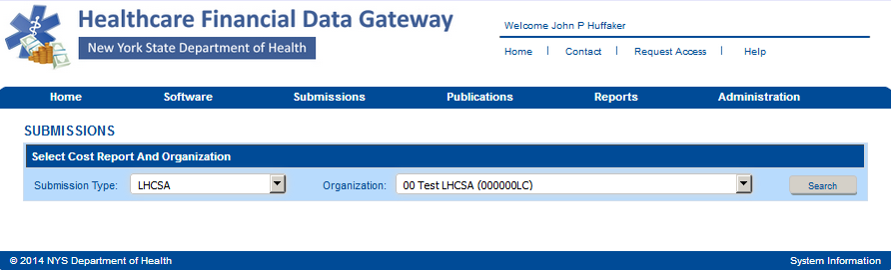

Submitting the Finalized Statistical Report continued…

- Select LHCSA or ALP_LHCSA as the Submission Type and your organization from the Organization list and then click the Search button. The Submission page will be expanded.

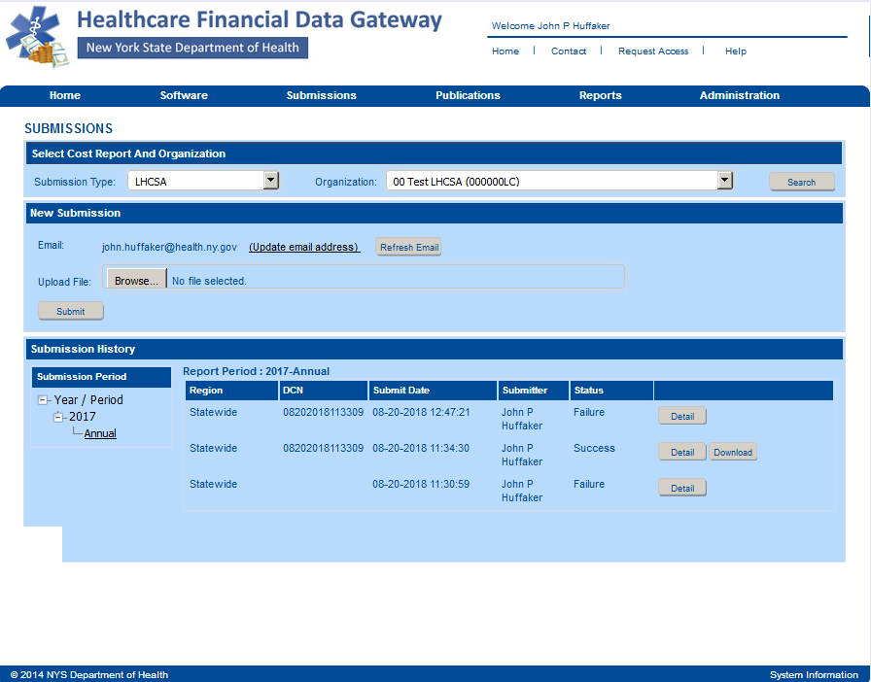

- Click the Browse button to display a dialog box that allows you to locate your finalized LHCSA Statistical Report. It will have a .pnp file extension.
- Once you have selected the file to submit, click the Submit button.
- The Submission History section of the Submission page will be updated to reflect the status of the submission.
- A confirming email message will be sent to the email address listed in the New Submission section of the Submission page.

